

GO GREEN GO E- Ferno

IR LED light strip kit 12 Volt. (Optional extra)
Installation & User Instructions
For use only with E-Ferno Azar range of electric fires.
LED strip light kit includes:
Power connection lead 12 volt.
LED light strip, (5 linear meters)
Remote control handset.
LED controller.

- WARNING | Please read the installation and user instructions completely taking special note of the safety information ensuring everything is fully understood before attempting to install, connect, and operate the LED strip light kit.
- CAUTION | Please keep the Installation and User instructions safe for future reference. Ensure the Installation and user instructions accompanies this product to any new owner or user of this product.

Issue 1

Contents

Section Heading Page

Front page 1

Contents 2

1.0 Health & Safety 3 – 4

2.0 Technical / Specification 4

3.0 How to connect 4 - 5

3.1 How to install 5 - 6

4.0 Control with IR remote 7

5.0 Control with App using a mobile phone. 8 - 11

6.0 Main User Interface. 12

6.1 Support 3rd Party Control. (Alexa & Google Home). 13 – 15

7.0 Electrical Waste Disposal. 15

1.0 Health & Safety
- Any electrical connections made whilst fitting this LED strip light kit must be made by a suitably qualified and registered electrician and meet the requirements of Current National laws, Local Laws, Building Regulations, and any Rules in Force.
- A recognised independent body for registered electricians in England, Wales, Scotland, and Northern Ireland is the National Inspection Council for Electrical Installation Contracting (NICEIC). Go to www.niceic where you will find a search facility to find NICEIC registered electricians.
- Installation of this LED strip light must be completed in accordance with current local codes and Regulations in each country. All local Regulations & any Rules in Force, including those which refer to National and European standards, must be observed when installing this product.
- It is highly recommended that this LED strip light kit is only installed within properties that have a suitable RCD consumer unit installed and in operation to all electrical circuits.
- The installer has a responsibility to ensure that all requirements of the Health & Safety at Work Act are observed & implemented as stated on the date of installation.
- Remove all packaging taking care that all parts are removed before responsibly disposing of the packaging at an appropriate recycling facility. Keep all plastic bags away from children.
- NEVER dispose of batteries used for operating this LED strip light kit (remote control handset) within a fire. Failure to observe this precaution may result in an explosion. Dispose batteries at your local hazardous material processing centre.
- Always disconnect the mains power lead plug from the mains power supply when the appliance with the optional extra LED downlight strips is not in use.
- The LED light strip is for indoor use only.
- The LED light strip kit must not be used in bathrooms, kitchens, laundry areas, swimming pool areas and similar indoor locations.
- Never locate the LED strip light kit where contact with water or any other fluid or humidity is possible.
- Do not use or install the LED light strip kit in areas where flammable gases, (for example petrol), flammable liquids, paint, solvents, aerosol spray, glue are used or stored as the LED light kit contains hot and / or sparking components within.
- Any replacement of circuitry or outlets should only be performed by a certified electrician.
- Only use the LED strip light kit as described in this instructions and user manual. Any other use not recommended by the manufacturer may cause fire, electric shock, or injury to persons and invalidate the guarantee.
- Never attempt to dismantle the LED strip light kit for any reason as this could result in an electric shock and serious injury, any repairs or replacement parts to this appliance must be undertaken by a suitably qualified electrician.
- For use only with the Newman Fireplaces Ltd, E-Ferno range of electric fires.
- Ensure all connections are positioned so as not to be a hazard.
2.0 Technical / Specification

Specification
Chip specifications: 5050.
Number of led: 30pcs / metre.
Light strip width: 10mm.
Maximum light strip length: 4-linear metres.
Power parameters: 4w / metre.
Working voltage: 12V DC.
Control method: Infrared remote control or APP control.

3.0 How to Connect

Step 1: Connect the LED strip lights to the LED controller lead, ensure the arrow of the LED controller lead is aligned to the 12volt marker on the LED light strip as shown.
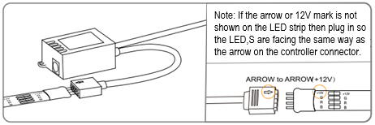
Step 2: Plug in the power lead supplied to the LED controller as shown. Note each end of the power lead uses the same male connection so either end can be used.
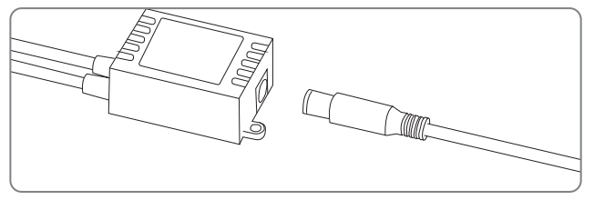
Step 3: Connect the other end of the power lead into the dedicated female connection within the E-Ferno electric fire.
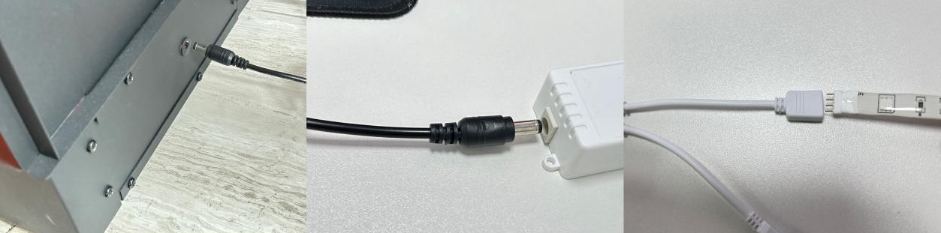

Step 4: Test the LED light strips by unwinding the strip lights from the reel, plug in the E-Ferno electric fire to a suitable mains supply, refer to the E-Ferno electric fire instructions, test the strip lights for operation.

3.1 How to install.
- The LED light strips will only adhere to surfaces that are, contamination free, smooth, flat, and dry.
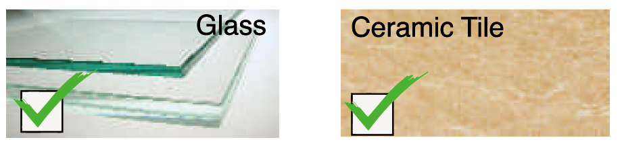
- The LED strip lights will not adhere any rough or contaminated surfaces.
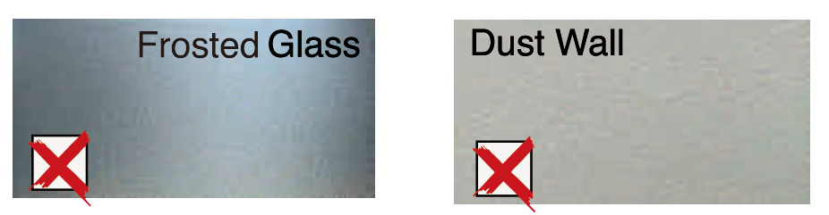

- Clean the surface being used and dry with a lint free cloth. Isopropyl alcohol is a good cleaning agent, refer to the manufacturer instructions.

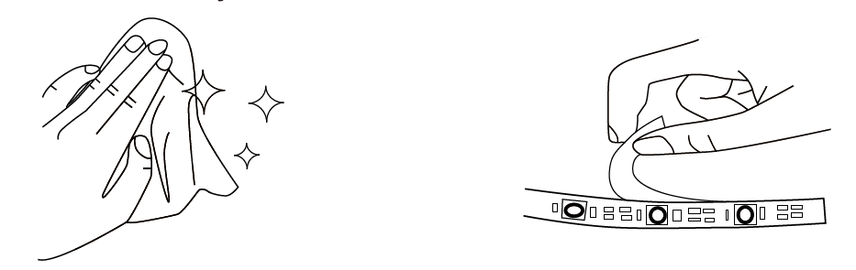

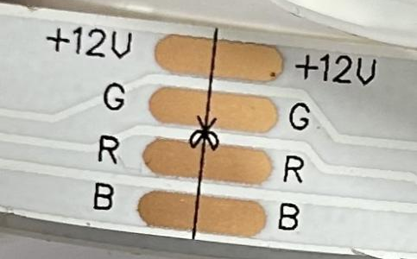
- The LED light strip must not be extended but can be shortened if required by cutting through one of the 4 horizontal copper bars closest to the length required.
WARNING: Ensure the power supply is switched off before cutting.

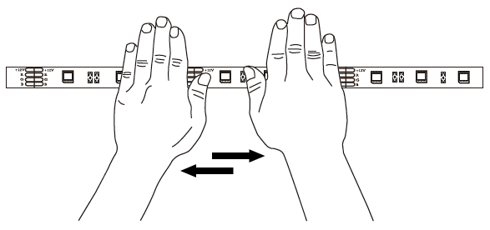
- Peel and remove the self-adhesive backing paper from the strip lights, carefully position to the fixing surface required, when happy with the position gently press the strip lights onto the surface and then press firmly along the length of the strip light ensuring a good bond has been made.
Note: Ensure the weight of the LED controller box and power lead is not supported by the self-adhesive LED light strip.

4.0 Control with IR remote.
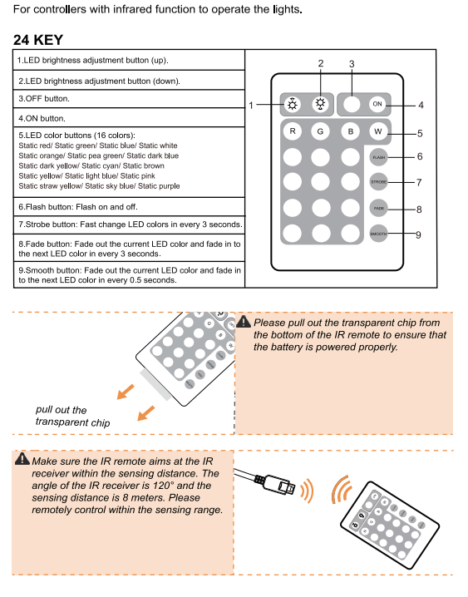

5.0 Control with App using a mobile phone.

Initialise the strip light device & LED strip light App download.
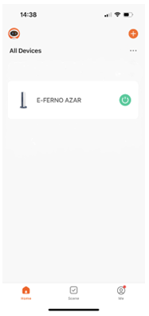

1. Refer to the E-Ferno instruction and User manual to download the appliance App.

2.
a) Press the sign located to the top right-hand
side of the screen.
b) Press Add device from the pop-up screen.

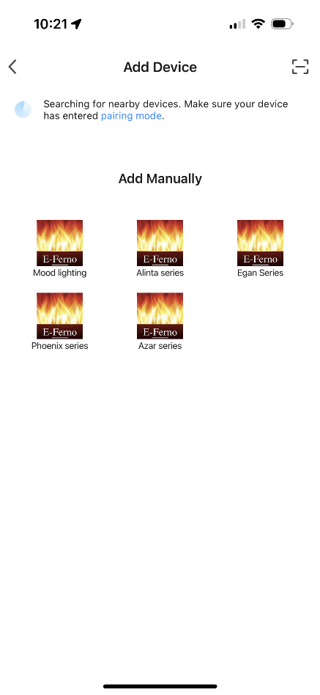

3. Select Mood lighting.

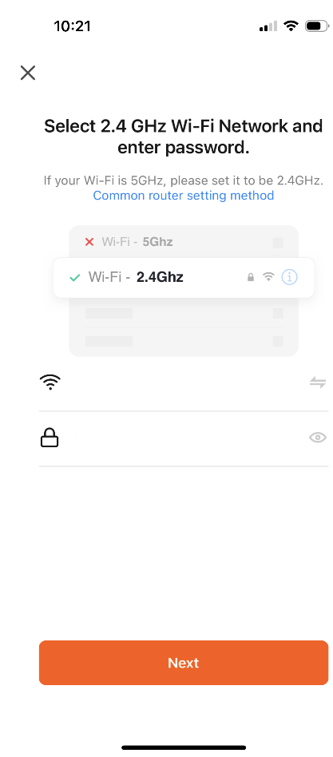
4.
a) Add home Wi-Fi.
b) Add password.
c) Press Next

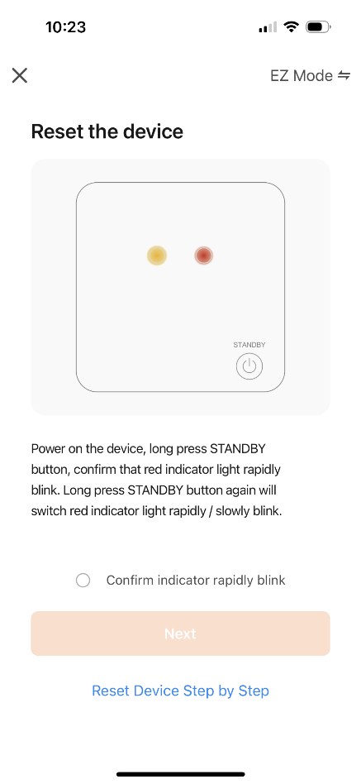
5.
- Turn the power on to the appliance.
- Using the handheld remote control, press and hold the on button for approximately 5 seconds or alternatively switch the power on / off, on / off, the strip lights should now be flashing on and off at a fast rate.
- Confirm the strip lights are blinking rapidly by pressing the circle alongside Confirm indicator rapidly blink
- Press Next.
- The pairing process should be completed within 3 minutes after the device is initialised, otherwise the connection may time out and fail requiring the process to be started again.
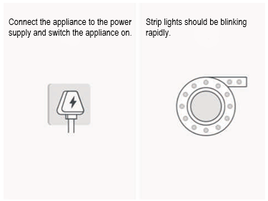

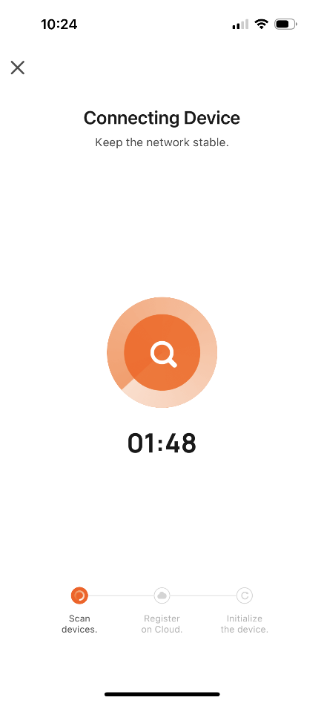
- Connection in progress, when paired will go to the page below.

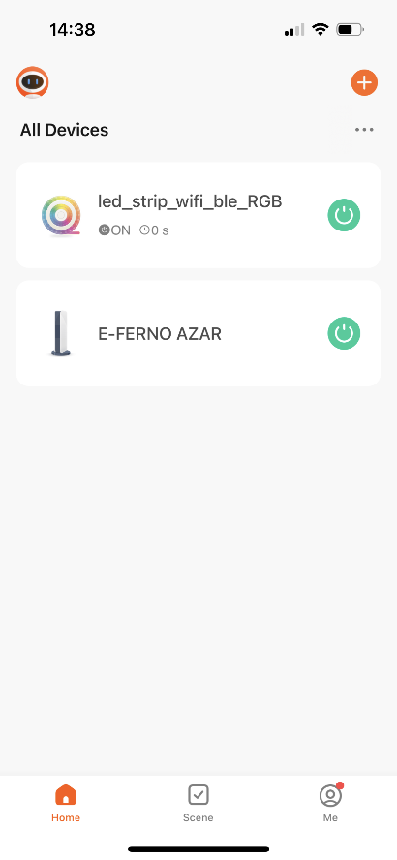

- The strip lights are now paired, ready for use.

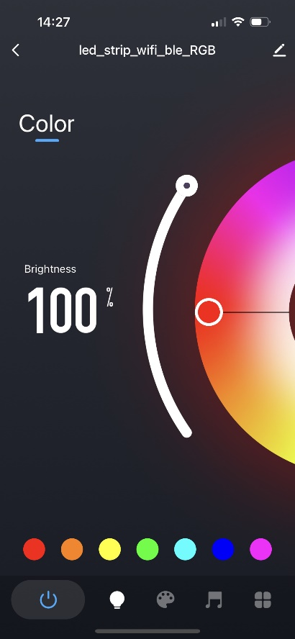
- You can now control the LED strip lights with the Tuya Smart App now.

6.0 Main User Interface.
      - Change the colour and brightness of strip lights.
      - Scene: Custom colour mode.
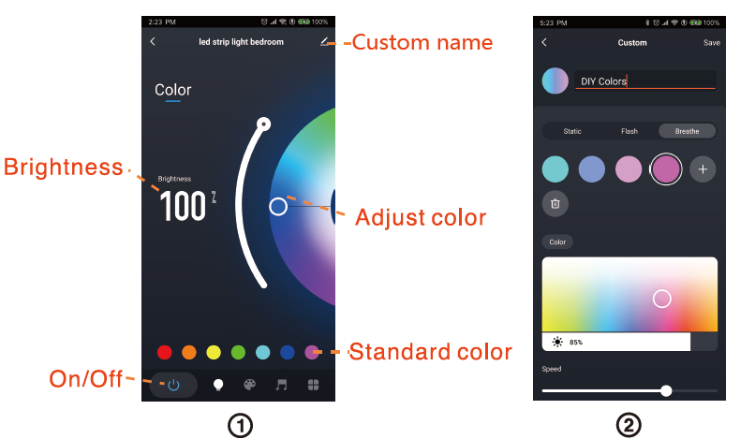
      - Music: Change the colour of the light strip by music rhythm.
      - Click ‘More’ to access the timer function.
      - Click ‘More’ to access the Countdown function.
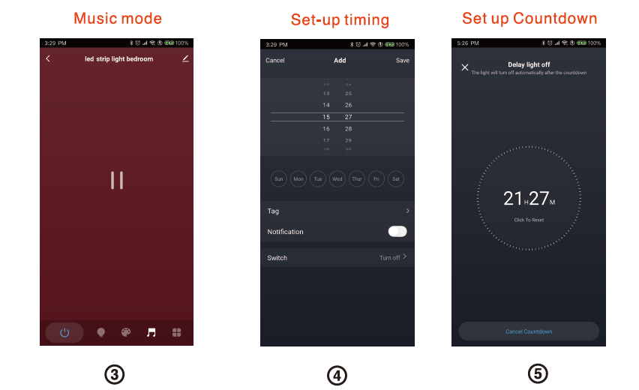

6.1 Support 3rd Party Control. (Alexa, & Google Home.
Select the ‘Me’ interface and then click ‘More Services’.
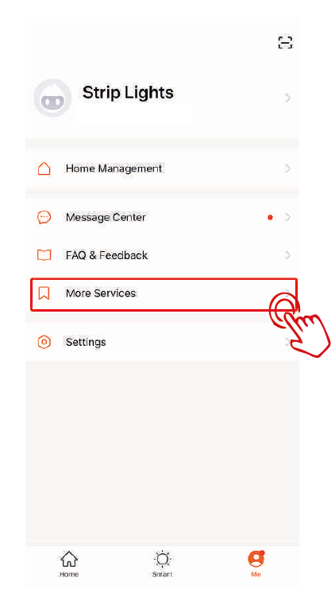

1. Select the ‘Me’ interface and then click ‘More Services’.

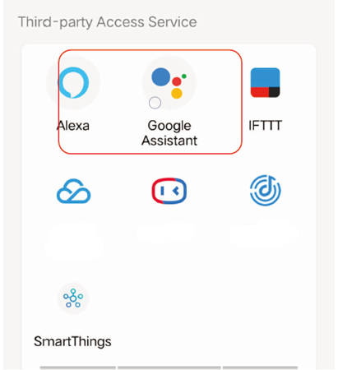
2. Select the third-party application to be operated.

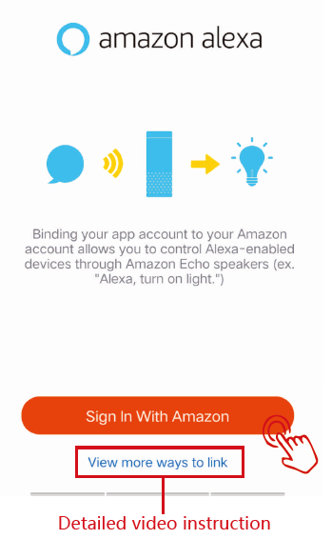
Click ‘sign in with Amazon’.

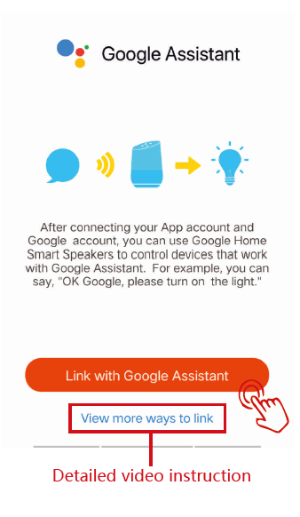

Click ‘Link with Google Assistant’

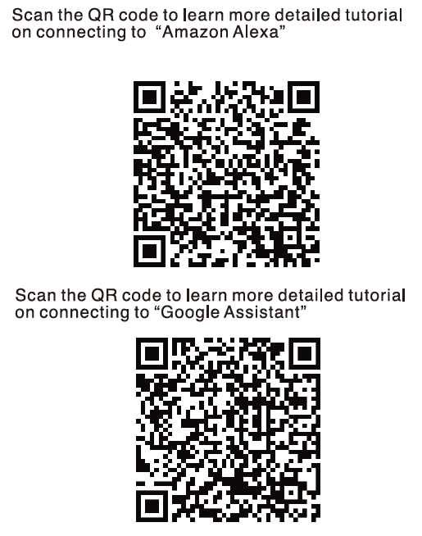

7.0 Electrical Waste Disposal
- Registration No WEE/DH1656ZW
In accordance with European Directive 2012/19/ EU, waste electrical and electronic equipment (WEEE) must not be disposed of with household waste.
Please recycle responsibly at your nearest electrical product recycling facility.

